Report On

“**Trends in Recommendation & personalization in netflix**”

By

Sanjana Asrani D17B/01

Nishtha Batra D17B/7

Varad Deshmukh D17B/22

Samarth Gawali D17B/25

Under the Guidance of

**Mrs. Abha Tewari**



Department of Computer Engineering

Vivekanand Education Society’s Institute of Technology

2023-24

**Table Of Contents**

**1.Problem Definition and Scope of Project**

1.1 Introduction

A **recommendation system** is a fancy way to describe a process that tries to predict your preferred items based on your or people similar to you. In layman’s terms, we can say that a Recommendation System is a tool designed to predict/filter the items as per the user’s behavior.

**Personalization** is the way to match the right types of services, products, or content to the right users to help improve user engagement. By utilizing ML algorithms and data, it is possible to create smart models that can precisely predict customer intent and as such provide quality one-to-one recommendations. At the same time, the continuous growth of available data has led to information overload — when too many choices complicate decision-making. Primarily developed to help users deal with the large range of choices they encounter, recommender systems come into play.

**Recommender systems / recommender engines** are information filtering systems that provide individual recommendations in real-time. As powerful personalization tools, recommendation systems leverage machine learning algorithms and techniques to give the most relevant suggestions to particular users by learning data (e.g., past behaviors) and predicting current interests and preferences.

1.2 Problem Definition and Scope of Project

This report is aimed at developing a movie recommendation system tailored for the **netflix dataset**. The system utilizes clustering techniques to group individuals with similar movie preferences and suggests movies that cater to the tastes of each specific cluster. This project addresses the challenge of providing personalized movie recommendations to diverse groups of people enhancing the overall entertainment experience.

1.3 Users of the system

1.4 Dataset

1. <https://www.kaggle.com/datasets/tmdb/tmdb-movie-metadata?select=tmdb_5000_movies.csv> is used in a notebook for webapp.
2. <https://www.kaggle.com/datasets/rounakbanik/the-movies-dataset?select=movies_metadata.csv> For comparison between content and collaborative filtering.

**2. Literature Review**

1. MovieREC, a recommender system for movie recommendation. It allows a user to select his choices from a given set of attributes and then recommend a movie list based on the cumulative weight of different attributes and using K-means algorithm. By the nature of our system, it is not an easy task to evaluate the performance since there is no right or wrong recommendation; it is just a matter of opinions.
2. We come up with a strategy that focuses on dealing with the user's personal interests and based on his previous reviews, movies are recommended to users. This strategy helps in improving accuracy of the recommendations personal profile is created for each user, where each user has access to his own history, his likes, ratings, comments, password modification processes. It also helps in collecting authentic data with improved accuracy and makes the system more responsive
3. The movies are a complex object and emotions are a human interaction, which is difficult to combine together. In this paper, we applied a matrix for integrating movie recommendation by hybrid approach, which consists of a CBF and CF system with an emotions detection algorithm and our algorithm. Furthermore our algorithm calculated the user rating 1 and 5 because the users absolutely liked or disliked the movies. This system gives much better recommendations to users because it enables the users to understand the relation between their emotional states and the recommended.
4. A movie recommendation framework based on hybrid recommendation and sentiment analysis is proposed to improve the accuracy of recommender systems. Furthermore, Spark is used to improve the timeliness of the system. Our proposed method makes it convenient and fast for users to obtain useful movie suggestions. Movie recommendation is a comprehensive task which involves various kinds of users and various kinds of movies. Considering the useful information hidden in reviews posted by users, collaborative filtering is considered to be the most popular and widely deployed technique in recommender systems.

**3.Conceptual System Design**

3.1 Conceptual System Design- CSD Diagram with explanation of each module.

3. 2 Methodology:

Implement collaborative and content based filtering using the datasets and make a comparison

Based on the better performing one, make a ui for easy user interaction.

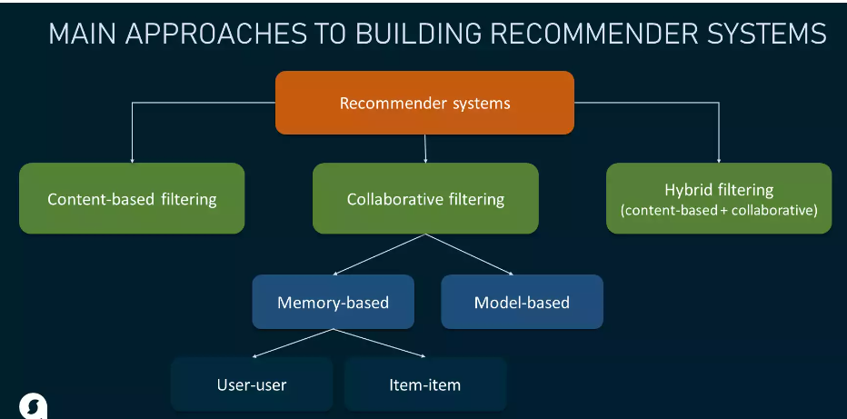

       3.2.1 Data Gathering / Loading

      3.2.2 Data Preprocessing , Descriptive Analysis

      3.2.3 Filtering

      3.2.4 Classification/ clustering etc

      3.2.5 Visualizations

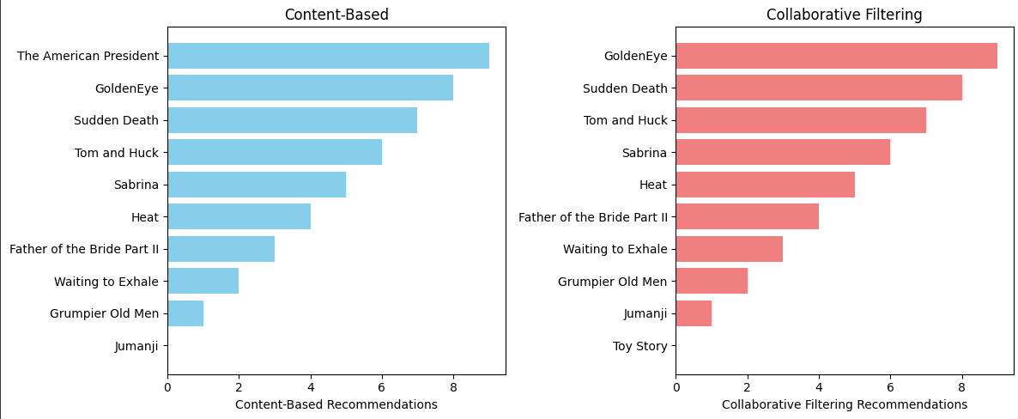

**4. Technology Used**

1. Streamlit: Streamlit is a popular Python library used for creating web applications with minimal effort. It's often used for creating interactive, data-driven web applications and dashboards.

2. Pickle: Pickle is a module in Python used for serializing (pickling) and deserializing (unpickling) Python objects. In your project, Pickle is being used to save and load a machine learning model. It allows you to persist the model so that it can be used outside of your Colab environment.

3. Colab: for the ML Model.

4. PySpark: instead of directly loading the datasets, it can be loaded using pyspark.

**5. Implementation**

Landing page:

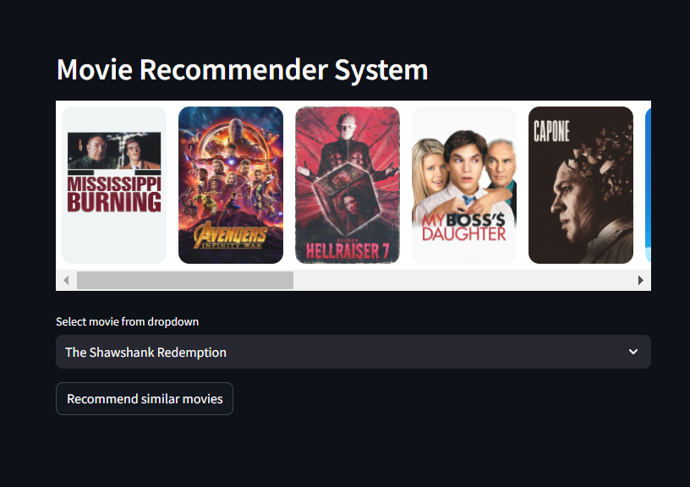

After you select a movie:

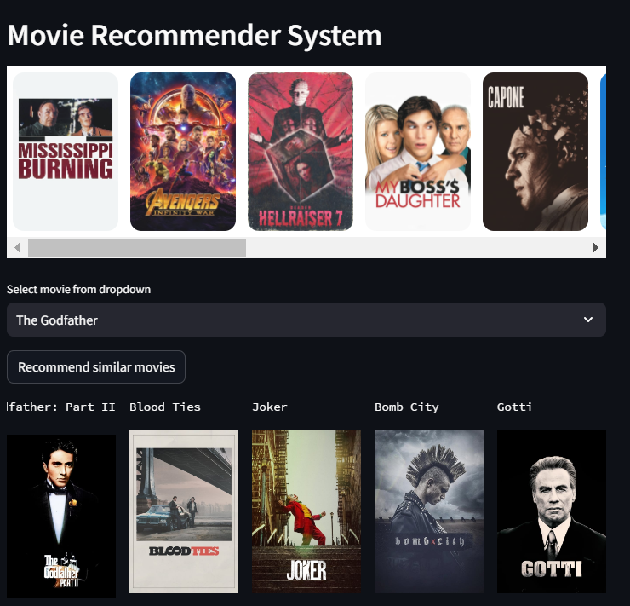

Notebook:

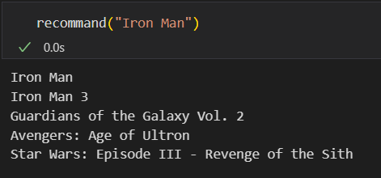

**6. Results and conclusion**

In this project, we have successfully developed a system using **TMDB** dataset along with analyzing the same algorithm on **Netflix** dataset using **PYSpark**. Future work could include allowing users to perform various operations on the data, including applying filters based on user preferences. For instance, users can discover movies similar in terms of director, storyline, or other attributes.

We have implemented advanced recommendation algorithms, such as **collaborative filtering** and **content**-**based** **filtering**, to provide more personalized movie recommendations. Additionally, we can incorporate user feedback and ratings to improve the accuracy of these recommendations. Furthermore, integrating natural language processing techniques for analyzing movie descriptions and user reviews can enhance the system's understanding of user preferences.

**7.References**

1. *Kumar, Manoj, D. K. Yadav, Ankur Singh, and Vijay Kr Gupta. "A movie recommender system: Movrec." International journal of computer applications 124, no. 3 (2015).*[*(PDF) A Movie Recommender System: MOVREC*](https://www.researchgate.net/publication/283042228_A_Movie_Recommender_System_MOVREC)
2. *Sharma, Poonam, and Lokesh Yadav Yadav. "Movie Recommendation System Using Item Based Collaborative Filtering." International Journal of Innovative Research in Computer Science & Technology (IJIRCST), ISSN (2020): 2347-5552.*[*Movie Recommendation System*](https://papers.ssrn.com/sol3/papers.cfm?abstract_id=3672412)
3. *Wakil, Karzan, Rebwar Bakhtyar, Karwan Ali, and Kozhin Alaadin. "Improving web movie recommender system based on emotions." International Journal of Advanced Computer Science and Applications 6, no. 2 (2015): 218-226.*[*Improving Web Movie Recommender System Based on Emotions*](https://pdfs.semanticscholar.org/5f8c/5280a647dcac6121fbd89d3fb9c31786e164.pdfArticle)
4. *Wang, Yibo, Mingming Wang, and Wei Xu. "A sentiment-enhanced hybrid recommender system for movie recommendation: a big data analytics framework." Wireless Communications and Mobile Computing 2018 (2018).*[*A Sentiment-Enhanced Hybrid Recommender System for Movie Recommendation: A Big Data Analytics Framework*](https://www.hindawi.com/journals/wcmc/2018/8263704/)